 |  | 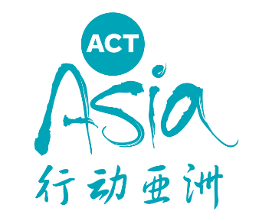
Application for ACTAsia Volunteer
*Please fill out the form and send back to info@actasia.org
1) Personal Information
1. Full Name: | 2. Gender:
3. Date of Birth: | 4. Location (City/District):
5. Nationality: | 6. Mobile Tel:
7. Wechat: | 8. E-mail:
9. Skype ID:
2) Background Information
1. University: | 2.Major:
3. Year of study:
4. Language Proficiency:
□ Chinese | □ English | □ Others (Please specify: )
○ Basic (comprehension) | ○ Basic (comprehension) | ○ Basic (comprehension)
○ Intermediate (oral and written communication) | ○ Intermediate (oral and written communication) | ○ Intermediate (oral and written communication)
○ Advanced (can use the language flexibly and accurately, can interact with a native speaker) | ○ Advanced (can use the language flexibly and accurately, can interact with a native speaker) | ○ Advanced (can use the language flexibly and accurately, can interact with a native speaker)
5. Name of Company (if applicable):
6. Past Work and Volunteer Experience:
7. Why would you like to join us and be a volunteer？
8. What animal issues concern you most? (e.g. Fur Free Life, Responsible Pet Ownership)
9. Interests and hobbies:
10. Special skills:
11. How did you hear about ACTAsia?
□ Online (e.g. websites, social media)
□ Offline (e.g. newspapers, magazines)
□ Word of mouth, or had participated in ACTAsia events before
□ Others (Please specify: ）
3) Preferred Tasks
1. Translations | □ EN-CN (written translation) | □ CN-EN (written translation)
 | □ EN-CN (oral translation) | □ CN-EN (oral translation)
 | □ Others (Please specify: ）
2. Media Operations | □ Article writing | □ Graphic design
 | □ Media cooperation | □ Web design
 | □ Video production | □ Data collection & research
 | □ Others (Please specify: ）
3. Event Planning & Coordination | □ Event planning (online & offline) | □ Event promotion
 | □ Event coordination | □ Marketing
 | □ Photography/videography
 | □ Others (Please specify: ）
4. Project Development | □ CFL materials design | □ Partnership development
 | □ Teach CFL course
 | □ Others (Please specify: ）
5. Others | □ General administrative tasks | □ Fundraising/promoting ACTAsia
 | □ IT support (Please specify softwares you're familiar with)
 | □ Others (Please specify)
6. How many hours per week are you able to volunteer with us?
7. For how long are you able to volunteer with us?
□ 3 months | □ 6 months | □ 1 year or more

